1. What is an Enterprise?

Enterprise is a any business or organization that provides service and aims to make a profit.

It can be a human skill to do something new and take the risk.

1. What is Architecture?  
   It  a set of rules stating how **computer** software and hardware are joined together and interact to make a **computer** work. It describes the structure and behavior of the system
2. What is Enterprise Architecture?  
   It is a high level strategic architecture. It is conceptual blue print that defines the structure and operation of organization. It helps to connect service, process, and people

Enterprise Architecture is an adaptive system. It should be able to collaborate the legacy system.

1. Why do you need a EA?  
   It is required to understand the business long term goals and design a strategy to achieve those goals. Eg minimize the cost or maximize profit
2. Who is an Enterprise Architect?  
   Enterprise Architect are highly experienced person who interact with the customers to understand their business needs for next two to three years. He is responsible for analyzing business structure and processes to see that they align with business goals effectively. He design the solution and long term strategy to reach the business goals. He might not know the low level functionality of the applications.
3. What is integration architecture?  
   It is a project specific architecture. It can be APIs project, ETL project, file transfer, event driven architecture
4. Difference between EA and Integration architecture?  
   Enterprise Architecture is a high level strategic architecture while integration architecture is a project specific architecture
5. What is a framework?  
   Frameworks are the tool the architects use to implement the architecture design.
6. How are frameworks useful for EA?  
   Frameworks helps EA to think from different perspective

1. What is TOGAF?  
   The Open Group Architectural Framework.

It helps an organization to achieve the business goal with a systematic approach and aims to reduce errors, work on timeline, stay on budget and align IT with business units. **It**  provides a set of process which follows **ADM**: Architecture Development Model

1. What is a Zachman?  
   This model is a guidelines that EA follows so that he does not miss anything while creating the architecture.

It is a structure way to view a business in two dimensional schema such that it cover the six stakeholder perspective: planner, owner, designer, builder, subcontractor and user. Then from each user perspective it tries to answer questions: Why, How, What, who, where and when that covers the different functionality of an enterprise.

1. What is 4+1 View point?  
   The 4+1 View Model separate the different aspects of a software system components into different views of a system. It describes software architecture using five concurrent views, each of which addresses a specific set of concerns

* Logical view: high level diagram, end user perspective diagram
* Development View: How to create a model, what technology is used . Look from developer perspective and focus on actual software developement
* Process View : it is in system integration perspective. We can use sequence diagram
* Physical view: Where the application is deployed and what framework is used. It considers the non-functional requirement of the system
* Scenario and use cases : use a scenario to view all the 4 views

1. When to use TOGAF, Zachman and 4+1 view point?
2. Real time use-case of using TOGAF framework?
3. Ream time use-case of using Zachman framework?
4. Real time use-case if using 4+1 View point?
5. When will you use API Led connectivity?  
   API led connectivity is an architectural approach to connect data to applications through reusable and purposeful assets
6. What is logical view, development view, process view, physical view?
   1. Logical view

* End user perspective.
* The logical architecture primarily supports the functional requirements
* It defines the services provides by the system to users
* Examples: Class Diagram, Object Diagram
  1. Development View:
* Developers perspective
* The development architecture focus on the actual software module organization on the software development environment.
* It helps us to understand how code modules work together and also understand the dependencies between modules
* Example: Component diagram, Package diagram
  1. Process View :
* System integrators perspective.
* It is closer to the working of an actual software.
* Process view consider non-functional requirements such as performance and availability
* The purpose of process view is to capture the sequence, timing and flow of inter-process information exchange
* Example: Sequence Diagram, Activity Diagram, State Diagram, Communication Diagram
  1. Physical view:
* Infrastructure perspective.
* Where application will be deployed, decide frame-work
* Physical architecture considers the non-functional requirements of the system such as availability, reliability, performance and scalability.
* Software executes on network of computers or processing nodes. Physical view illustrate which node will host which process from the process view.
* Example: Deployment diagram, Network topology

1. Explain these views with an example?  
   i. Logical view: Looks from end user perspective.

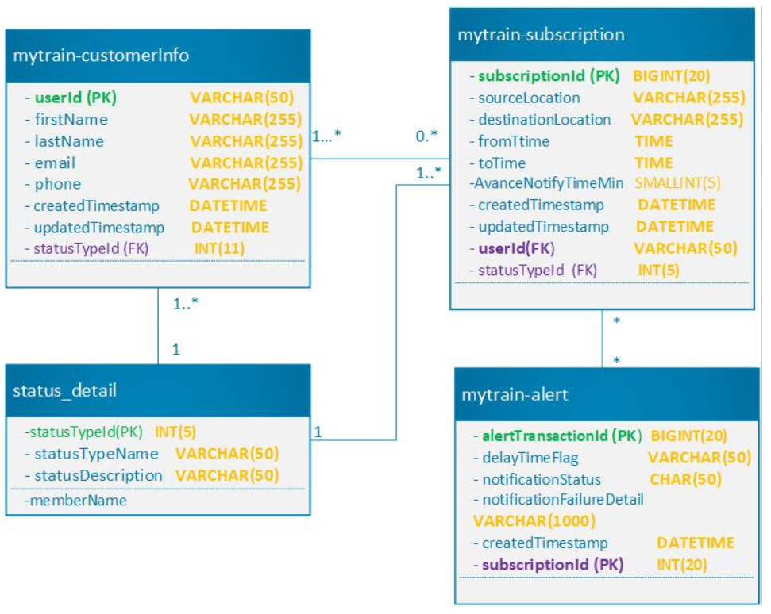

ii. Process view: Looks at system integration perspective and focus on non functional requirements

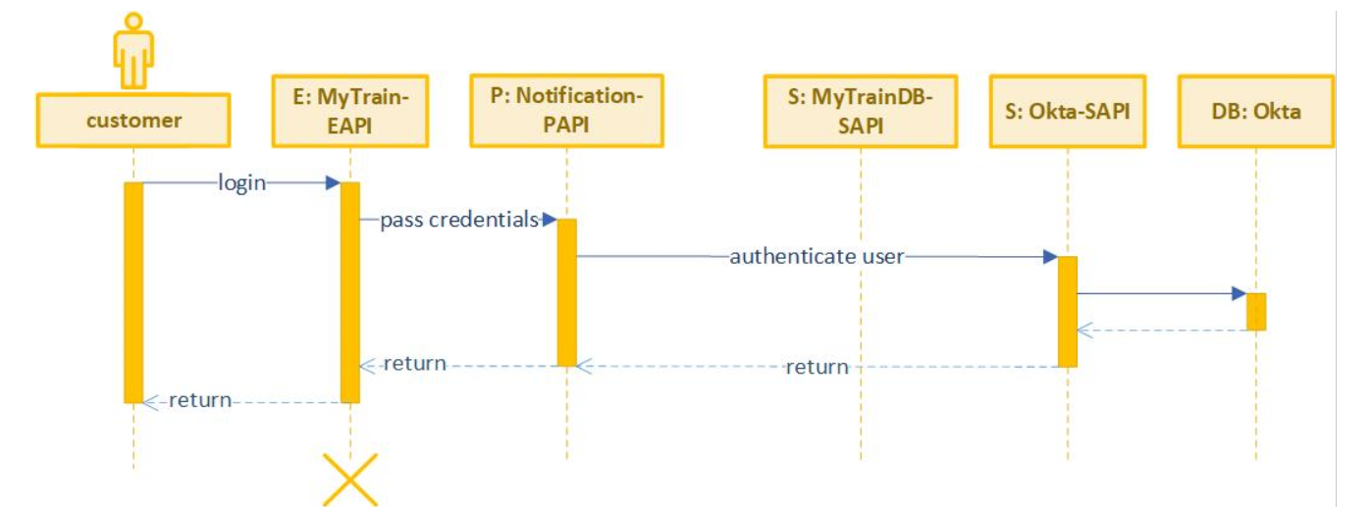

iii. Physical view: looks from infrastructure perpective

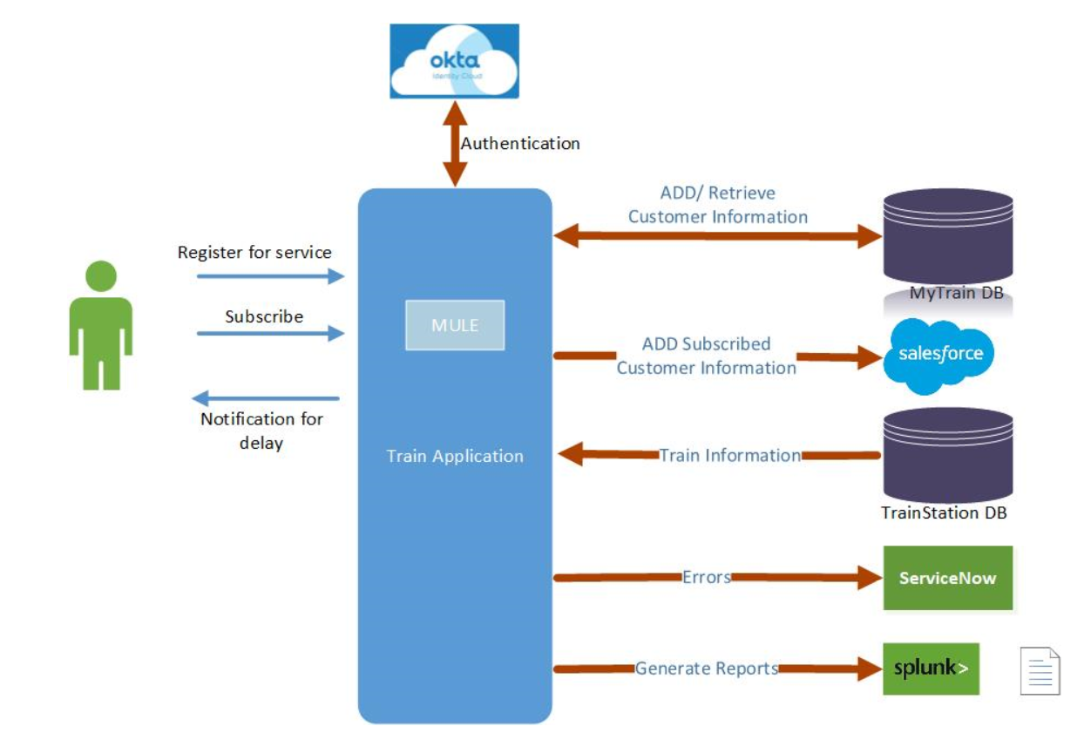

iv. Development view



v. Scenario

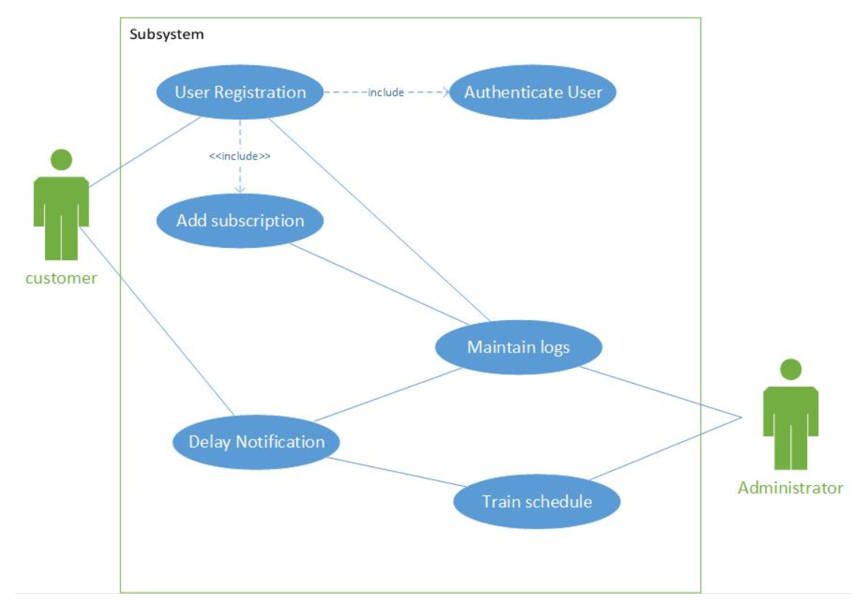

1. What tools do you use to create each of the views in 4 + 1 view points?
   1. Logical View: Class, object, state, composite, structure
   2. Process: sequence, Activity, Timing, Interaction overview diagrams
   3. Development View: Component and package diagram
   4. Physical view: Deployment diagram
   5. Use case: Use case diagram or user stories
2. . What do you achieve or what is the purpose of creating these views in 4+1 view model?
3. What is SOA?  
   “Service-oriented architecture” is a style of software design where services are provided to the other components by application components, through a communication protocol over a network. The basic principle of service-oriented architecture is independent of vendors, products, and technologies
4. What is a micro service?  
    It is an architectural style that structures an application as a collection of services that are

* Highly maintainable and testable
* Loosely coupled
* Independently deployable
* Organized around business capabilities
* Owned by a small team

Difference between SOA and Microservice?  
**service-oriented architecture (SOA)** has an enterprise scope, while **the microservices** architecture has an application scope.

* **Communication:** In a microservices architecture, each service is developed independently, with its own communication protocol. With SOA, each service must share a common communication mechanism called an [enterprise service bus (ESB)](https://www.ibm.com/cloud/learn/esb). The ESB can become a single point of failure for the whole enterprise, and if a single service slows down, the entire system can be effected.
* **Interoperability:**In the interest of keeping things simple, microservices use lightweight messaging protocols like HTTP/REST. SOAs are more open to heterogeneous messaging protocols.
* **Service granularity:**Microservices architectures are made up of highly specialized services, each of which is designed to do one thing very well. The services that make up SOAs, on the other hand, can range from small, specialized services to enterprise-wide services.
* **Speed:** By leveraging the advantages of sharing a common architecture, SOAs simplify development and troubleshooting. However, this also tends to make SOAs operate more slowly than microservices architectures, which minimize sharing in favor of duplication.

1. What is EDA? with a use-case or example?  
   An event-driven architecture uses events to trigger and communicate between decoupled services and is common in modern applications built with microservices. An event is a change in state, or an update, like an item being placed in a shopping cart on an e-commerce website.

Example: an e-commerce site

When a customer place an order for an item an event is triggered. The event router will direct the event to ware house management to check the stock for availability of the item. If the item is avaialbe it is added to the cart.

1. What is ETL? with a use-case or example?

ETL is a type of data integration that refers to the three steps (extract, transform, load) used to blend data from multiple sources. It's often used to build a [data warehouse](https://www.sas.com/en_us/insights/data-management/data-warehouse.html). During this process, data is taken (extracted) from a source system, converted (transformed) into a format that can be analyzed, and stored (loaded) into a data warehouse or other system.   
**Marketing data integration:** Marketing data such as web analytics, social media information or consumer data is moved into a place using ETL for further analyzation.

**Database Replication:** ETL tool can be used to derive data from many databases including, MySQL, PostgreSQL, and Oracle and transfer it into a cloud warehouse.

Design Centre

1. What is RESTFul API ?

A RESTful API is an architectural style for an application program interface ([API](https://searchapparchitecture.techtarget.com/definition/application-program-interface-API)) that uses HTTP requests to access and use data. That data can be used to GET, PUT, POST and DELETE data types, which refers to the reading, updating, creating and deleting of operations concerning resources

1. What is a Non-Restful API?

The APIs that do not follow REST architecture are called not restful APIs

If the API does not follow REST principle then its called a non restful api

1. Characteristics of a RESTFul API?

The RESFul API must follow REST principles. These are

* Stateless,
* Cacheable,
* Client-server,
* uniform Identifier,
* layered system,
* Code on demand

1. What is the use of designing an API?

Designing an API means providing an effective interface that helps your API’s consumers better understand, use and integrate with them while helping you maintain it effectively

1. Is it mandatory to design an API? Explain.

Its not mandatory to design an API

But dseigning an API have various advantages

* ensure faster code
* allows to get feed back from the team and the customer at at early stage about requirement and changes if needed
* helps to create better functioning API

1. What ways can we design a RESTFul API?

We can desing RestFul API using RAML, OAS and APIary

1. What is RAML?

RAML stands for RESTful API Modeling Language. RAML is a [YAML](https://en.wikipedia.org/wiki/YAML)-based language for describing [RESTful](https://en.wikipedia.org/wiki/RESTful) [APIs](https://en.wikipedia.org/wiki/API). It provides a structured and clear format to describe the API. It can be used in a multitude of ways: to implement interactive API consoles, generate documentation, describing an API you are planning to build, and more.

1. What is OAS?

OAS stands for Open API. It was developed by Reverb Technologies in 2010 and named as Swagger. It was designed to solve the need for keeping the API design and documentation in sync. It is a type of framework that was designed to describe, produce, visualize, and consume RESTful web services. It can be written in JSON or YAML. The recommend language is YAML, because it is easier to read and write.

1. What is APIARY?

Apiary is a platform that uses [API Blueprint](https://apiblueprint.org/) (a markdown related syntax) to help you create the design of your API and generate the documentation, detect syntax errors, and even create a mock API, so you can start testing without having to write a single line of code

<https://developers.messagemedia.com/api-design-using-apiary/>

https://tsh.io/blog/apiary-api-documentation-tool/

1. What are the differences between RAML vs OAS vs APIARY?

|  |  |  |  |
| --- | --- | --- | --- |
|  | **RAML** | **OAS** | **APIARY** |
| **Goals** | Provides all the necessary information to describe RESTful API | Keep documentation, client libraries and source code in sync | It has an online interface and integrates with API Blueprint, a high-level API description language that sits atop Markdown |
| **Current version** | RAML Specification 1.0 | Open API Specification 3.0.1 | Apiary Interactive Documentation v4 |
| **Supporters** | MuleSoft, Agular, PayPal, Cisco,VMware | Google IBM, Microsoft, Atlassian | Oracle, github |
| **Code Language** | Node.js, .NET, Python, Mule, IOT | Node.js, .NET, Python, Mule, IOT, PHP, Ruby, Swift, Java, JavaScript |  |
| **Document Format** | YAML | JSON, YAML | API blueprint , JSON, YAML |
| **Editors** | API WorkBench | Swagger Tools | Apiary Editor |

1. When should you use each of these languages?

There is not strict rules on which API to choose. It depends on the developers choice

* If you want to generate documentation automatically you may use OAS or APIARY
* If the choice is to build, test, implement and maintain the APIs from a single point then RAML will be a best choice

1. Example of RAML and OAS?

**Raml Example**

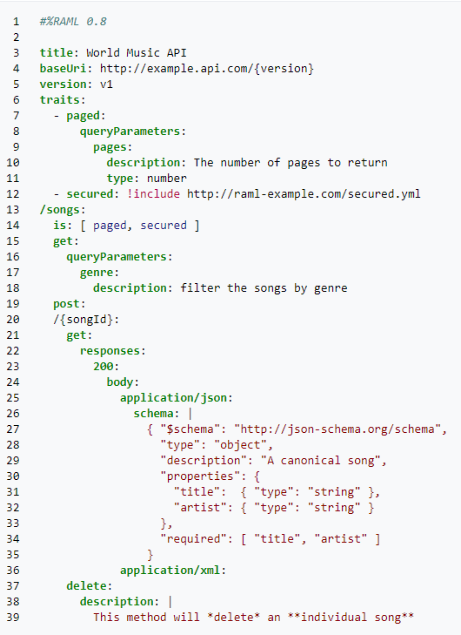

**Example of OAS**

openapi: 3.0.0

info:

version: 1.0.0

title: Simple API

description: A simple API to illustrate OpenAPI concepts

servers:

- url: https://example.io/v1

components:

securitySchemes:

BasicAuth:

type: http

scheme: basic

security:

- BasicAuth: []

paths:

/artists:

get:

description: Returns a list of artists

# ----- Added lines ----------------------------------------

parameters:

- name: limit

in: query

description: Limits the number of items on a page

schema:

type: integer

- name: offset

in: query

description: Specifies the page number of the artists to be displayed

schema:

type: integer

# ---- /Added lines ----------------------------------------

responses:

'200':

description: Successfully returned a list of artists

content:

application/json:

schema:

type: array

items:

type: object

required:

- username

properties:

artist_name:

type: string

artist_genre:

type: string

albums_recorded:

type: integer

username:

type: string

'400':

description: Invalid request

content:

application/json:

schema:

type: object

properties:

message:

type: string

1. What ways can you design a Non-RESTFul API?

We can design non restful apis using following ways:

* RPC
* SOAP
* GraphQL
* Async API

1. Explain GraphQL API with example?

GraphQL is a *query language* for APIs. At its core, GraphQL enables *declarative data fetching* where a client can specify exactly what data it needs from an API. Instead of multiple endpoints that return fixed data structures, a GraphQL server only exposes a single endpoint and responds with precisely the data a client asked for

1. Explain RPC with example?

RPC – Remote Procedure Call enables “Call a function on another server.” An API is built by defining public methods; then, the methods are called with arguments. RPC is just a bunch of functions, but in the context of an HTTP API, that entails putting the method in the URL and the arguments in the query string or body.

It use only GET and POST, with GET being used to fetch information and POST being used for everything else. Example to “send a message” the syntax is as below:

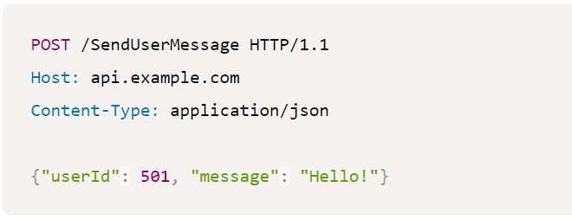

1. Explain SOAP with an example?

SOAP is the Simple Object Access Protocol. It is an open-standard, XML-based messaging protocol for accessing web services over HTTP. SOAP uses an XML data format to declare its request and response messages, relying on XML Schema and other technologies to enforce the structure of its payloads. It uses Web Service Description Language (WSDL) wot write API. This API description language defines the endpoints and describes all processes that can be performed. It defines the operations available and what input/output fields to expect.

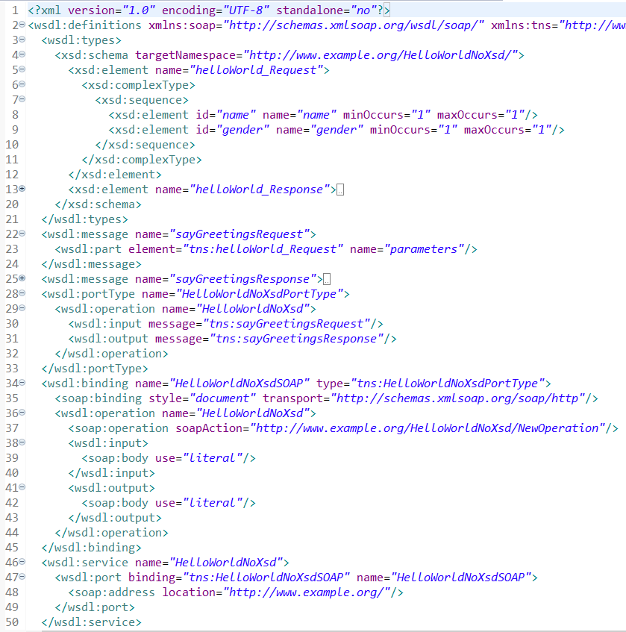

1. Explain Async API with example?

Async API is based on an event driven architecture. It uses a method by which an API can be represented using a commonly defined and understood language. It support YAML and JSON language to write API

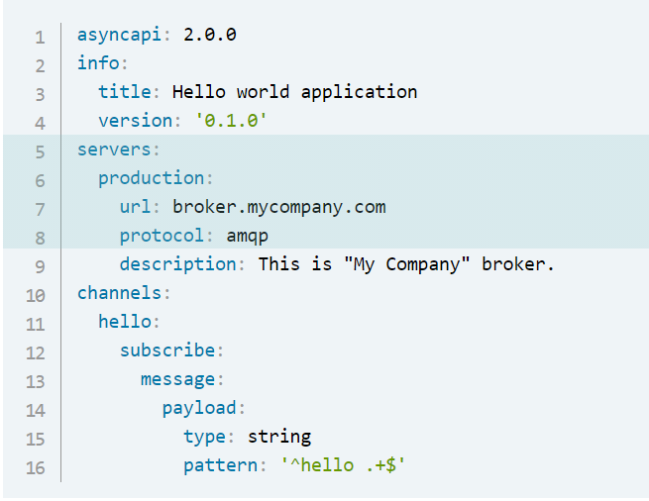

1. . What are the constraints of REST?

The constrains of rest are:

* Uniform Interface
* Stateless
* Cacheable
* Client-Server
* Layered System
* Code on Demand

1. What is connectedness, stateless and unique resources in REST means?

* **stateless**

Implementing stateless requests means the communication between consumer and service is initiated by the request, and the request contains all the information necessary for the server to respond. Session state is kept entirely on the client. Statelessness makes a service more reliable and easier to scale. Statelessness promotes session independence. Because of session independence, any server can process the client request. This makes load balancing possible. The trade-off of statelessness is that it increases network bandwidth since every information needs to be passed in every request.

* + **Connectedness**

The client and server know about each other only during the session. So client need to send all the required information so that server can response.

Since client and server are lossely couples they are independent and can be updated independent of one another

* + **unique resources**

By applying the software engineering principle of generality to the component interface, the overall system architecture is simplified and the visibility of interactions is improved. In order to obtain a uniform interface, multiple architectural constraints are needed to guide the behavior of components. REST is defined by four interface constraints:

1. identification of resources;
2. manipulation of resources through representations;
3. self-descriptive messages; and,
4. hypermedia as the engine of application state (HATEOAS).
5. What is hypermedia?

**hypermedia**” refers to any content that contains links to other forms of media such as images, movies, and text.

1. Why do you want to use hypermedia?

REST architectural style lets us use the hypermedia links in the response contents. It allows the client can dynamically navigate to the appropriate resources by traversing the hypermedia links.

1. What is Richardson Maturity Model? Explain?

The Richardson Maturity Model is a way to grade your API according to the constraints of REST. The better your API adheres to these constraints, the higher its score is. The Richardson Maturity Model knows 4 levels (0-3), where level 3 designates a truly RESTful API.

### Level 0: Swamp of POX

Level 0 uses its implementing protocol (normally HTTP, but it doesn't have to be) like a transport protocol. That is, it tunnels requests and responses through its protocol without using the protocol to indicate application state. It will use only one entry point (URI) and one kind of method (in HTTP, this normally is the POST method). Examples of these are SOAP and XML-RPC.

### Level 1: Resources

When your API can distinguish between different resources, it might be level 1. This level uses multiple URIs, where every URI is the entry point to a specific resource. Instead of going through <http://example.org/articles>, you actually distinguish between <http://example.org/article/1> and <http://example.org/article/2>. Still, this level uses only one single method like POST.

### Level 2: HTTP verbs

This level suggests that in order to be truly RESTful, your API **MUST** use HTTP verbs.

This level indicates that your API should use the protocol properties in order to deal with scalability and failures. Don't use a single POST method for all, but make use of GET when you are requesting resources, and use the DELETE method when you want to delete a resources. Also, use the response codes of your application protocol. Don't use [200](http://httpstatus.es/200) (OK) code when something went wrong for instance. By doing this for the HTTP application protocol, or any other application protocol you like to use, you have reached level 2.

### Level 3: Hypermedia controls

Level 3, the highest level, uses HATEOAS to deal with discovering the possibilities of your API towards the clients. More information about HATEOAS can be found below.

1. Explain how to use a visual editor in the design centre.

To use visual editor in the design center, follow the below steps

* Go to design center in anypoint platform
* Then select create API specification
* Then add the RAML name. Select visual editor, select latest RAML and press create specification

1. What are API Fragments?

API fragments are reusable component of RAML to make the design and build of a reusable API even quicker and easier

1. Why do you need Fragments?
   * Fragment enables to reuse the components in different projects
   * It is an important factor to minimize the IT delivery gap
2. Explain data type with example?

**Data Types**, a concise and versatile way to describe and validate data inside your API definition.

Some of the data types available in RAML are string, integer, data-time etc

1. Explain Traits with examples?

Traits is like function and is used to define common attributes for HTTP method (GET, PUT, POST, PATCH, DELETE, etc) such as whether or not they are filterable, searchable, or pageable

When a trait is created it is referenced by using **is** key word

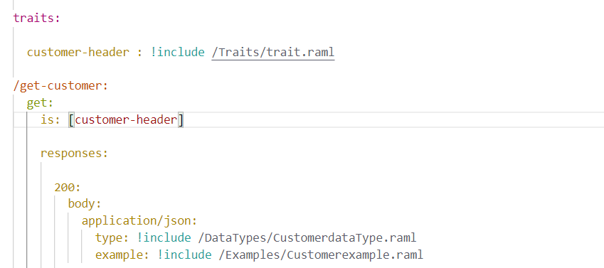

1. Explain Library with example?

* Libraries provide the ability to bring in pre-defined sets of data-types, resourceTypes, traits, security schemas, and reusable assets - all in a namespaced environment
* When we want to define more than one datatype in a single file so that easy data retrieval and editing can be done. In such scenarios we can go for Libraries.

1. Explain Examples with examples?

* Example fragment is used to define the example response of some operations we are doing in the RAML spec.

Example fragment is used to define the NamedExample

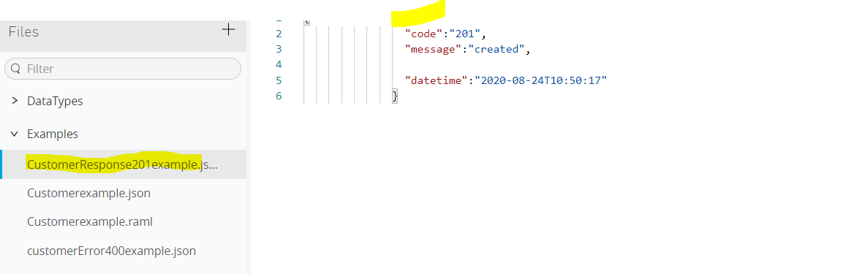

1. Difference between an example and examples?

#### Single Example

The OPTIONAL **example** facet can be used to attach an example of a type instance to the type declaration. There are two ways to represent the example facet value: as an explicit description of a specific type instance and as a map that contains additional facets.

title: Attention needed

body: You have been added to group 274

#### Multiple Examples

The OPTIONAL **examples** facet can be used to attach multiple examples to a type declaration. Its value is a map of key-value pairs, where each key represents a unique identifier for an example and the value is a [single example](https://github.com/raml-org/raml-spec/blob/master/versions/raml-10/raml-10.md/#single-example).

message: # {key} - unique id

# example declaration

title: Attention needed

body: You have been added to group 274

record: # {key} - unique id

# example declaration

name: log item

comment: permission check

1. What is data-modelling?

**Data integration modeling** is a technique that takes into account the types of **models** needed based on the types of architectural requirements for **data integration** and the types of **models** needed based on the Systems Development Life Cycle (SDLC)

1. What are the different approaches to create data-models?

There are many approaches to create a data model

The most used are

* CANONICAL / COMMON DATA MODELLING
* Bounded Context
* Mirror a Backend System

1. What is a canonical data model?

Canonical data models are a type of data model [that aims](https://www.techopedia.com/definition/30598/canonical-data-model-cdm) to present data entities and relationships in the simplest possible form in order to integrate processes across various systems and databases. More often than not, the data exchanged across various systems rely on different languages, syntax, and protocols. A CDM is also known as a common data model

1. What is Enterprise wide data-model?

Enterprise **data modeling** (EDM) is the practice of creating a graphical model of the data used by an enterprise or company. Typical outputs of this activity include an Enterprise **Data Model** consisting of entity–relationship diagrams (ERDs), XML Schemas (XSD), and an **enterprise wide** data dictionary

1. What are the advantages and disadvantages of an enterprise wide data-model?
2. What is a bounded context data model?

The bounded context concept originated in Domain-Driven Design (DDD) circles. It is a way of modeling a large domain as independent sub-domains. It promotes an object-model-first approach to a service, defining a data model that a service is responsible for and is "bound to." DDD deals with large models by dividing them into different Bounded Contexts(BC) and being explicit about their interrelationships.

1. What is mirroring a data-model in a backend system?  
   A mirror backup is an exact copy of the selected folders and files from the source being backed up. Mirror backups are unique in that when you delete a file from the source, that file will eventually be deleted on the mirror backup

**Exchange**

1. What are connectors?

Anypoint Connectors are reusable extensions to Mule runtime engine (Mule) that enable you to integrate a Mule app with third-party APIs, databases, and standard integration protocols. All connectivity in Mule 4 is provided through connectors.

Using connectors in a Mule app provides the following advantages:

* Reduces code complexity, because you can connect a Mule app to a target system without knowing all of the details required to program to the target system
* Simplifies authenticating against the target system
* Proactively infers metadata for the target system, which makes it easier to identify and transform data with DataWeave
* Makes code maintenance easier because:
  + Not all changes in the target system require changes to the app.
  + The connector configuration can be updated without requiring updates to other parts of the app.

1. What are the different types of connectors?

There are 4 types of connectors mulesoft provide

* 1. Select
  2. Premium
  3. Mulesoft certified
  4. Community

1. What is a REST connector?

The Exchange backend uses REST Connect to transparently convert a REST API specification to a Mule 3 and Mule 4 connector. You can use this connector as you would any other in Anypoint Studio. REST Connect does not currently support custom TLS configurations.

1. What is a SELECT Connector?

These connectors are developed by mulesoft. These are open source, so anyone can use it but the mulesoft support is provided only to the Anypoint platform subscribers. Example: File connectors, object store, database, http, email

1. What are premium connectors?

These connectors are developed by mulesoft. In order to use it customer need an active cloud hub premium plan or enterprise subscription. Example AS2, FTP, Anypoint custom metrics

1. What are mulesoft certified connectors?

These are developed by mulesoft partners and developer community and reviewed by mulesoft. In order to get the support for these connectors one need to contact the mulesoft partners. Example Google analytics connectors, Atlassian Jira REST connectors and Microsoft office 365 excel connectors

1. What are community connectors?

The MuleSoft or members of the MuleSoft community write and maintain the Community connectors. These are generally open-source and free to use. Example SLACK connectors and HubSpot Connector

1. What is a custom connector?

Custom connectors are the connectors created by the mulesoft developers community.

We can develop our own connector using the new Mule SDK platform for Mule Runtime 4

1. How to create a custom connector?

The pre requisite to create a custom connector are

1. Java JDK Version 8.x
2. Anypoint Studio 7.x
3. Apache Maven 3.3.9 or higher

https://dzone.com/articles/how-to-create-a-custom-connector-in-new-mule-sdk-4